Title: Using A Non-Infectious MVM Surrogate For Assessing Viral Clearance During Downstream Process Development
Authors: Joshua D. Orchard¹, David Cetlin², Melanie Pallansch³, Robert Barlow¹, Jon Borman¹, Arun Dhar³, Luke Pallansch⁴, Matthew Dickson⁵
MedImmune¹, MockV Solutions², University of Arizona³, Texcell North America⁴, Viela Bio (formerly at MedImmune)⁵
Abstract
Viral contamination is an inherent risk during the manufacture of biopharmaceuticals. As such, biopharmaceutical companies must demonstrate the viral clearance efficacy of their downstream process steps prior to clinical trials and commercial approval. This is accomplished through expensive and logistically challenging spiking studies which utilize live mammalian viruses. These hurdles deter companies from analyzing viral clearance during process development and characterization. We utilized a non-infectious Minute Virus of Mice - Mock Virus Particle (MVM-MVP) as a surrogate spiking agent during small scale Viral Filtration (VF) and Anion Exchange Chromatography (AEX) studies. For VF experiments, in-process mAb material was spiked and processed through Asahi Kasei P15, P20, P35 and BioEX nanofilters. Across each filter type, flux decay profiles and Log Reduction Values (LRV) were nearly identical for either particle. For AEX experiments, loads were conditioned with various amounts of sodium chloride (9, 20, 23 and 41 mS/cm), spiked with either particle and processed through a Q-SFF packed column. LRV results indicated comparable removal of either particle at all conditions tested.
Introduction
Downstream bioprocess development is a data driven discipline. Whether identifying an optimal pH window for operating a column chromatography step, analyzing the flux decay profile of a virus filter or assessing the yield achieved from a novel separation technology, decisions stem from the assessment of available analytical data. In general, the ultimate goal of downstream bioprocess development is to optimize product purity while maintaining the highest possible product yield¹. For recombinant products, such as monoclonal antibodies derived from mammalian cell lines, product purity is achieved through the reduction of host-cell derived “impurities” - including endogenously expressed host-cell proteins (HCP), cellular DNA and product variants or degradation products (e.g. aggregates) that could have an impact of drug safety or efficacy. Through the application of well-established analytical techniques, such as Enzyme Linked Immunosorbent Assays (ELISA) and quantitative Polymerase Chain Reaction (qPCR), the reduction of some impurities can be routinely assessed²⁻⁶. The relative availability and practicality of impurity reduction methods is invaluable to the field of process development as it enables a steady supply of scientific information to guide the evolving process.

For most companies, viral clearance is an aspect of bioprocess development that falls outside the realm of practical assessment. Although critical, the demonstration of virus clearance is not routinely assessed during process development or characterization and is, instead, delayed until validation⁷. This is due to the high costs and logistical complexities involved in performing viral spiking studies⁸⁻⁹. With this high barrier to obtaining data, chromatography and filtration parameters are often solidified on the basis of separation theory and historical data with little to no process-specific information regarding viral clearance efficacy.

We’ve addressed these barriers of high cost and logistics associated with viral clearance through a novel use of Virus Like Particles (VLPs). VLPs are multiprotein structures that mimic the morphology and surface characteristics of native infectious viruses but are themselves non-infectious¹⁰. These properties have made VLPs an interesting class of molecules for potential use as vaccines¹¹, but these same features also make VLPs ideal for use as BSL-1-compatible analytical process development tools. In this study, the major capsid protein of Minute Virus of Mice (MVM) was expressed in a recombinant system to form empty VLP’s, referred to here as MVM-Mock Virus Particles, “MVM-MVP’s”. These purified MVM-MVP’s have been shown to be physicochemically similar to MVM¹² and during a previous study, the feasibility of predicting MVM nanofiltration clearance through the use of MVP’s was demonstrated¹³. The approach of utilizing an MVM-MVP for clearance studies involves the following: 1) introduction of MVM-MVP into an in-process matrix, 2) processing the spiked matrix through a separation technique, and 3) quantification of MVM-MVP removal from the matrix. To quantify MVM-MVP removal, an Immuno-qPCR assay (I-qPCR) has been established to analyze the MVM-MVP content of samples generated during a separation experiment. This technique currently provides a dynamic range of ~ 3.0 log₁₀ particles/mL, and although short of enabling “robust” clearance results (due to assay background limitations), early results support the potential of utilizing MVM-MVP’s to predict MVM clearance¹³. If proven, this approach could enable the practical and economic prediction of MVM removal, thereby allowing the routine study of viral clearance during process development and characterization.
The present study aimed to assess the overall merit of utilizing a non-infectious MVM-MVP to predict MVM removal. Both accuracy of prediction and practicality of approach were investigated. To determine MVM prediction accuracy, a series of parallel MVM-MVP and MVM spiking studies were conducted utilizing in-process monoclonal antibody (mAb) matrices provided by MedImmune (Gaithersburg, MD). Anion Exchange mode of chromatography (AEX) and virus filtration (VF) modes of separation were investigated. Log₁₀ Reduction Value (LRV) comparisons between each particle type served as the basis for predictability assessment. It was hypothesized that for each mode of separation, complete clearance of MVM-MVP would be achieved in instances where complete MVM clearance was determined and complete passage of MVM-MVP would occur in instances where complete passage of MVM occurred. When utilizing parameters that led to partial MVM clearance, it was expected that MVM-MVP LRV’s, as determined by I-qPCR, would be ± 1.0 LRV of MVM as determined by TCID₅₀. To determine the practicality of the overall approach, MVM-MVP sample stability was tested through long-term MVM-MVP-spiked matrix hold-time studies. The reproducibility and robustness of the I-qPCR assay was scrutinized by conducting sample analysis at multiple sites and through spike/recovery matrix interference evaluations.

Methods and Material
Monoclonal Antibody Matrix Preparations
Representative in-process mAb material was produced in CHO cell culture. The harvested material was purified through a Protein A column and eluted using 50 mM sodium acetate, pH 3.6. Viral inactivation was performed by low pH using 248 mM glycine, pH 2.3 and neutralized using 0.5 M tris. A portion of material was diluted with 50 mM Tris, pH 7.4 (Matrix ID 1, Table 1) and stored at -80°C. The resulting material was referred to as Matrix ID 3 (see Table 1). A separate portion of neutralized virus inactivated product was diluted with 50 mM Tris, 1 M sodium chloride, pH 7.4 (Matrix ID 2, Table 1) and stored at -80°C. The resulting material was referred to as Matrix ID 4 (see Table 1). A final portion of neutralized virus inactivated product was further processed through anion exchange chromatography, adjusted to pH 5.0 using 1 M acetic acid and adjusted for conductivity by adding 50 mM sodium acetate, 1 M sodium chloride, pH 5.0. The resulting material was referred to as Matrix ID 5 (see Table 1). The pI range of the mAb was between 8.4 and 8.9. Table 1 summarizes the final conditions of the Matrices used throughout the study. Conductivity and pH measurements of Matrix IDs 1 – 5 were measured by a calibrated meter upon final dilution.
Table 1: Matrix Identification Key
Matrix ID | Composition | mAb Concentration (mg/mL) | pH | Conductivity (mS/cm)
1 | 50 mM Tris | NA | 7.4 | 9
2 | 50 mM Tris, 1 M NaCl | NA | 7.4 | 19
3 | mAb + Matrix 1 | 12 | 7.4 | 22
4 | mAb + Matrix 2 | 12 | 7.4 | 44
5 | mAb + 50 mM sodium acetate, 1 M NaCl | 10 | 5.1 | 13

Four separate conditions of mAb were prepared for AEX chromatography. Each condition (referred to as A through D) was prepared by dialyzing Matrix ID 3 in 6 diavolumes of designated Dialysis Buffer (see Table 2) for two hours followed by a second dialysis with fresh buffer for an additional two hours. Post-dialysis conductivity adjustments were performed using 50 mM Tris, 1 M sodium chloride, pH 7.5 to meet the targeted conductivity. The conductivity adjusted material was then diluted with 50 mM Tris, pH 7.5 to ensure all matrices had a mAb concentration of 12 mg/mL. All matrices were filtered after dialysis and adjustments were made using a 0.2 µm filter (VWR aPES, Cat# 97066-204).
Table 2: AEX Preparation Key
AEX Condition | Dialysis Buffer Composition | Final Conductivity (mS/cm) | Final pH
A | 50 mM tris, 70 mM NaCl | 9 | 7.5
B | 50 mM tris, 180 mM NaCl | 19 | 7.6
C | 50 mM tris, 210 mM NaCl | 22 | 7.6
D | 50 mM tris, 430 mM NaCl | 41 | 7.6

MVM-MVP and MVM Production and Analysis
For MVM-MVP production, a previously described recombinant system was utilized to express the major VP2 capsid protein of MVM¹². The self-assembling particles were then purified by gradient centrifugation. Fractions containing MVM-MVP (according to SDS-PAGE with Coomassie Blue staining) were pooled and dialyzed into a proprietary formulation buffer. MVM-MVP morphology was determined through negative staining Transmission Electron Microscopy (TEM) and titer was determined through negative staining TEM with latex bead enumeration according to previously published protocols¹². Stock was then diluted to 12.0 log₁₀ particles/mL in formulation buffer. For MVM, strain Prototype [P] was propagated at Texcell N.A. (Frederick, MD). Initially, A9 cells were grown in serum-free media, and the expressed virus was subsequently purified by ultracentrifugation and mixed-mode chromatography, per proprietary procedures. Morphology was assessed by negative staining TEM.
Infectivity Analysis
To measure MVM infectivity and determine titers of samples generated in the course of this study, 324K cells were seeded in growth medium in 96-well plates at a density that resulted in 5-20% confluence the following day. After seeding, the plates were incubated overnight, and the 324K cells were inoculated with prepared samples (process, control, and toxicity and interference sample dilutions) at a volume of 0.1 ml per well. Plates were incubated for 7 days at 37°C and 5% CO₂. At the assay endpoint, each well was scored as positive for cytopathic effect (CPE) or negative for CPE. The TCID₅₀ assay endpoint is based on a quantal measurement of virus-induced cytopathic effects (CPE) and is defined as the virus dose capable of infecting 50% of the inoculated cells. The viral titer is calculated based on Spearman-Karber analysis of virus infectivity data and the resultant mean titer, along with its 95% confidence intervals, are reported.

MVM qPCR Analysis
Virus titer (copies/mL) and corresponding LRVs were also determined using qPCR. Viral DNA extraction was performed using QIAamp DNA Mini Kits (Qiagen, Germantown MD). Following the DNA extraction, samples were tested using the qPCR assay procedure described below. Briefly, all samples collected during the process were tested at dilutions that enable the virus to be quantified directly by comparison to an external MVM DNA standard. The qPCR Master Mix contained 2X Universal Master Mix (ThermoFisher, Carlsbad CA), forward primers, reverse primers, probes, and nuclease-free water. The Bio-Rad iCycler thermal cycler with iQ5 Multicolor Real-Time PCR Detection System software was used to perform the qPCR assay and to analyze the output data to calculate the final virus titer of each sample (copies/mL).

Immuno-qPCR Analysis
A previously described Immuno-qPCR (I-qPCR) assay¹³ was utilized to measure MVM-MVP and MVM quantity of experimental samples generated during the course of the study. In short, study samples were added to microwells coated with anti-MVM-MVP polyclonal antibody (MockV Solutions, Rockville MD). After incubating at room temperature, a biotinylated preparation of the anti-MVM-MVP capture polyclonal was added and washed. NeutrAvidin was added and washed before a biotinylated oligonucleotide was introduced and washed. Recovery buffer was then added to each well and plates were heated at 95°C for 5 minutes. After a quick centrifugation to remove condensate, analyte was then transferred to an empty PCR plate. qPCR was then performed according to set cycling parameters in a 25 µL reaction containing 5 µL of sample and primers/probe directed against the oligonucleotide. To determine the quantity of particles in unknown samples, threshold cycle (Ct’s) values were interpolated into a standard curve generated by a 10-fold dilution series of known MVM-MVP concentrations. No MVM-MVP “buffer blank” samples were run alongside every MVM-MVP dilution series performed during the study. To determine the Limit of Quantification (LOQ), a one-tail Student’s t-test, assuming unequal variances, was then performed between the buffer blank data set and the accumulated data set from the MVM-MVP dilution series to identify the lowest detectable quantity (i.e., LOQ) of MVM-MVP that was significantly (α = 0.05) above the buffer background signal. To test assay robustness across sites and operation, samples generated in the study were analyzed by Texcell N.A. and independently by MedImmune.

I-qPCR Matrix Interference and Stability Study
To determine if in-process material would interfere with I-qPCR results, MVM-MVP was spiked into each matrix shown in Table 1 to a concentration of 7.0 log₁₀ particles/mL. Dilutions of each starting matrix (1:2 and 1:10) were also prepared with Phosphate Buffered Saline (PBS) and were subsequently spiked with MVM-MVP to a final concentration of 7.0 log₁₀ particles/mL. The analysis of I-qPCR results from these samples were compared to results obtained from spiking PBS alone with MVM-MVP to the same concentration. As a negative control, un-spiked matrices were also tested.
To understand the impact that sample storage temperature and time had on MVM-MVP quantitation, MVM-MVP was introduced into Matrices 1-5 (Table 1) at concentrations of 6.0 and 9.0 log₁₀ particles/mL and immediately analyzed via I-qPCR. In addition, aliquots of each spiked matrix/concentration were stored at 4°C and -80°C and removed for I-qPCR analysis after 4, 7, 14 and 21 days. Separately, aliquots of Matrices 2 and 4, were spiked to 9.0 log₁₀ particles/mL and freeze/thaw cycled between -80°C and 25°C three times before quantifying MVM-MVP via I-qPCR.

Virus Filtration Experiments
Virus filtration experiments were carried out with 0.001 m² PlanovaTM and BioEX virus filtration units (Asahi Kasei Medical Co., Ltd., Japan). First, a series of preliminary experiments were performed to determine the optimal MVM-MVP spiking challenge for PlanovaTM virus filtration. 8.0 log₁₀, 9.7 log₁₀ and 11.0 log₁₀ total MVM-MVP particles were spiked into three separate loads containing ~110 mL of Matrix 5. After sampling these three loads and a control load containing Matrix 5 without MVM-MVP, material was processed through buffer-equilibrated 20N filters (0.001 m²) at 13 psi. Filtrate mass was monitored and recorded throughout each run at 1-30 min intervals and once a volumetric throughput of 100 L/m² was attained, product collection was ended, and the system pressure was released. At this point, during a 30-minute no-pressure/ no-flow hold, equilibration buffer was added to the load reservoir, the system was re-pressurized to 13 psi and an additional 15 L/m² of processed chase was collected. Load, product and chase were frozen at -80◦C for several weeks until MVM-MVP quantity analysis was performed via I-qPCR. From these values, LRVs were calculated (see section below on LRV calculation).
After an 11.0 log₁₀ total MVM-MVP particle spike was deemed optimal (see Results), 15N, 20N, 35N and BioEX filters were processed with 100 L/m² of Matrix 5 spiked to a target 11.0 log₁₀ MVM-MVP or 8.0 log₁₀ TCID₅₀ MVM at 13 psi (15N, 20N and 35N) or 48 psi (BioEX). Baseline runs in which neither particle was spiked into Matrix 5 were processed through each filter as well. Product collection and post-load buffer chase were performed as previously described. Filtrate mass was monitored and recorded as a function of throughput and mAb yield was determined by spectrophotometry (Nanodrop, ThermoFisher). Samples collected from MVM experiments were analyzed via TCID₅₀ and additional aliquots were stored at -80◦C for I-qPCR analysis. Samples collected from MVM-MVP experiments were aliquoted for independent I-qPCR analysis at Texcell N.A. and MedImmune. Load samples were analyzed neat and diluted 1:10 in PBS. For each MVM experiment LRVs were calculated, according to the equation noted below, from TCID₅₀ and I-qPCR results while LRVs for MVM-MVP experiments were determined solely through I-qPCR values.
AEX Gradient Scouting
A 1.15 x 21.5 cm Vantage L column (Millipore, Burlington MA) was packed with Q Sepharose Fast Flow resin (GE, Marlborough MA) and qualified according to vendors recommendation. MVM-MVP stock solution was spiked into 244.5 mL of Matrix 3 (pH 7.7, conductivity 9.0 mS/cm) to a final target concentration of 9.0 log₁₀ particles/mL and a load sample was taken. The column was installed onto an AKTA Avant system (GE, Marlborough MA) and equilibrated with 3 column volumes (CV) of 50 mM tris, 70 mM sodium chloride, pH 7.5 at 300 cm/hr. Spiked load was then delivered to the column and a flow through “product” collection was initiated at an Optical Density (OD) of 0.5 at 280nm. Load was followed immediately with equilibration buffer (same as above), and collection was ended at an OD of 0.5 at 280nm. Following post-load equilibration, a 0-40% gradient of 50 mM tris,1.0 M sodium chloride, pH 7.5 was pumped through the column over ten CV while 15 “gradient” fractions (14.9 mL each) were collected. Finally, three CV of 40% 50 mM tris, 1.0 M sodium chloride, pH 7.5 was pumped through the column while a “strip” fraction was collected. The column was then sanitized with 1.0 N sodium hydroxide and stored with 0.1 N sodium hydroxide. The conductivity and protein concentration of each gradient fraction was analyzed, and mAb step yield was determined as the amount of protein recovered in the flow through product compared to the amount loaded. To initially gauge the MVM-MVP elution profile, the 15 gradient fractions were combined into pools of 3 (combining equal volumes of fractions 1-3, 4-6, etc.) and analyzed via I-qPCR along with the load, product and strip fraction samples. After reviewing the results of pooled samples, several individual fractions were analyzed as well.
AEX: MVM vs. MVM-MVP
Based on the MVM-MVP elution profile from the gradient experiment (see Results), four target load conditions were chosen to compare MVM vs. MVM-MVP clearance on the AEX column. Material preparations were made as described above (see Method section and Table 2). For MVM spiked runs, MVM stock was added to the 0.2 µm filtered (VWR aPES, Cat# 97066-204) test matrices to a final target concentration of 9.0 log₁₀ TCID₅₀/mL. For MVM-MVP spiked runs, MVM-MVP stock was added to achieve a final target concentration of 9.0 log₁₀ particles/mL and spiked materials were filtered through a 0.2 µm filter. For each run, the same Q-SFF column used for the gradient experiment described above was equilibrated with three CV of buffer that matched the testing condition of the load matrix (Table 2), at 300 cm/hr. Spiked load was then delivered to the column and a flow through “product” collection was initiated at an OD of 0.5. Load was chased immediately with equilibration buffer, and product collection was ended at an OD of 0.5. 3 CV of 50 mM tris, 430 mM sodium chloride, pH 7.5 was pumped through the column while a “strip” fraction was collected. The column was then sanitized with 1.0 N sodium hydroxide and stored with 0.1 N sodium hydroxide. To reduce inter-run product or particle carry-over, the column was pre-equilibrated with a high salt solution (50 mM tris, 430 mM sodium chloride, pH 7.5) before each run. In addition, all MVM-MVP spiked runs were concluded before MVM spiked runs. Step yields for all runs were determined from measured protein concentrations in load and product samples, and samples were analyzed by I-qPCR (MVM and MVM-MVP) and TCID₅₀ (MVM). LRVs were calculated from I-qPCR and TCID₅₀ analysis of MVM-MVP and MVM samples, respectively according to the equation below.

LRV Calculation
MVM and MVM-MVP LRV’s were calculated throughout this study as shown in the equation below:
$$LRV = \log_{10 }\left\{\frac{(Cl x Vl)}{(Cp x Vp)}\right\}$$
where C is the MVM or MVM-MVP particle concentration (via TCID₅₀ for MVM or I-qPCR for MVM-MVP), V is the volume and l or p denote load or product, respectively. Unless otherwise noted, chase or strip samples were not included in LRV determinations.

Results
Characterization of MVM-MVP and MVM
According to TEM analysis, the purified MVM-MVP stock solution was comprised of 95% intact, spherical particles with a diameter ranging from 16.2 to 26.6 nm and a mean particle diameter of 20.8 nm. In comparison, MVM has been cited to be between 18.0 and 28.2 nm^{12,14}. Morphologically, the particles appeared similar to MVM (Figure 1). The titer of MVM-MVP was determined to be 12.7 log₁₀ particles/mL before dilution to 12.0 log₁₀ particles/mL. The MVM stock solutions used in this study possessed high titers, low contamination of host-cell DNA and protein, and a virion monomeric content >90% as determined by dynamic light scattering (data not shown). According to infectivity analysis, the titer of purified MVM preparations was approximately 8.5 log₁₀ TCID₅₀/mL.
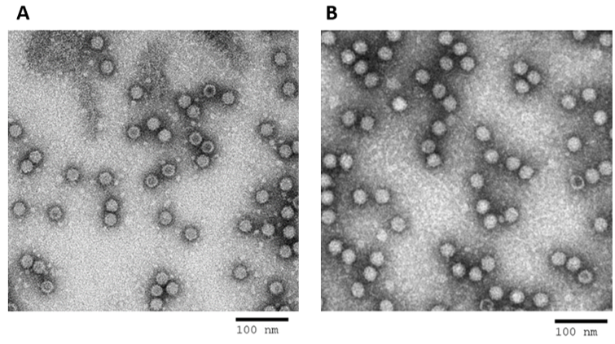
Figure 1: TEM images of (A) MVM-MVP used in this study and (B) MVM previously produced by Texcell, shown for comparison only.
I-qPCR LOQ and Standard Curve Results
During the course of the study, ten separate 10-fold dilution series of known MVM-MVP quantities (10.0 log₁₀ – 5.0 log₁₀) were analyzed by I-qPCR along with seven sets of no MVM-MVP “buffer blank” samples. The threshold cycle (Ct) values from these samples served to establish an assay LOQ and standard curve for determining the MVM-MVP quantity of unknown samples generated during the study. Figure 2a shows the average MVM-MVP Ct values, with standard error, at each concentration point of the MVM-MVP dilution series (blue data points). From these data, a line of best fit was calculated between 6.0 – 9.0 log₁₀ particles/mL. Average Ct values resulting from the analysis of the seven buffer blank sample sets (orange “X” data points, Figure 2a) were back-calculated to an “MVM-MVP concentration” by extrapolating from the line of best fit. These “MVM-MVP concentrations” signify assay background since no actual particles were present in the buffer blank samples. Similarly, the overall buffer blank Ct average (18.6) was back-calculated to an MVM-MVP concentration of 5.7 log₁₀ particles/mL (orange diamond data point, Figure 2a). The lower assay LOQ (LLOQ) was determined by comparing the Ct values of all the buffer blank samples to all of the 6.0 log₁₀ particles/mL dilution series samples by a Students T test (Figure 2b). The results from this test indicate a significant difference between the signal generated by the buffer blank samples and the 6.0 log₁₀ particles/mL dilution series samples. Thus, a LLOQ of 6.0 log₁₀ particles/mL was established and the line of best fit previously utilized between 6.0 -9.0 log₁₀ particles/mL became the technical standard curve (Figure 2a, yellow line and equation) – from which the MVM-MVP concentration of all unknown study samples was determined.
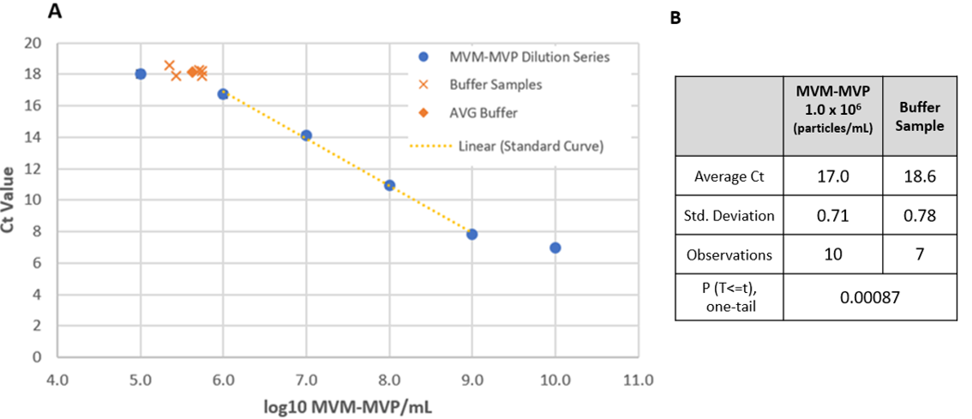
Figure 2: A) Plot of average MVM-MVP dilution series I-qPCR Ct values (blue dots) and average buffer blank sample Ct’s (orange X) generated during the course of the study. The overall buffer blank sample average is depicted as a solid orange diamond. The assays standard curve is shown (orange dots) from 6.0 -9.0 log₁₀ particles/mL with the equation and fit. B) Statistical comparison between MVM-MVP Ct data at concentration of 6.0 log₁₀ particles/mL and buffer blank Ct data. The Students T test value of 0.00087 is below the threshold of 0.05 indicating a statistically meaningful difference between the two data sets.
Matrix Interference and Hold Time
A comparison of I-qPCR assay performance in the presence of sample matrix and PBS was undertaken to determine the minimal dilutions necessary to overcome sample matrix interference when measuring MVM-MVP concentrations. MVM-MVP was spiked to a target concentration of 7.0 log₁₀ particles/mL into “undiluted” Matrix 1-5 (Table 1) and Matrix 1-5 diluted 1:2 and 1:10 with PBS. Matrices 1 and 2 contained only buffer components (no protein) while matrices 3-5 also contained mAb (see Table 1). MVM-MVP was also spiked to a target concentration of 7.0 log₁₀ particles/mL into PBS as a spiked recovery control. Results from I-qPCR quantification demonstrate that recoveries of MVM-MVP in undiluted matrices were ± 0.15 log₁₀ particles/mL of the spiked recovery control results (Table 3). Recoveries from diluted Matrices were all ± 0.25 log₁₀ particles/mL of the spiked recovery control results except for 1:10 diluted Matrix 1 and 3 (≥ -0.76 and -0.36 log₁₀ particles/mL, respectively). All non-spiked matrix controls were below the lower limit for I-qPCR quantification.

Table 3: Spike/Recovery Results from Matrices 1-5 spiked with MVM-MVP. Total log₁₀ particles/mL and values relative to PBS are shown.
Matrix ID | Undiluted |  | 1:2 PBS |  | 1:10 PBS |  | Non-spiked (control)
 | log₁₀ particles/mL |  | log₁₀ particles/mL |  | log₁₀ particles/mL |  | log₁₀ particles/mL
 | Total | +/- to PBS | Total | +/- to PBS | Total | +/- to PBS | Total | +/- to PBS
PBS (Control) | 6.76 | NA | 6.76 | NA | 6.76 | NA | ≤ 6.00 | NA
1 | 6.68 | -0.08 | 6.51 | -0.25 | ≤ 6.00 | ≥ -0.76 | ≤ 6.00 | 0.00
2 | 6.71 | -0.05 | 6.81 | 0.05 | 6.71 | -0.05 | ≤ 6.00 | 0.00
3 | 6.61 | -0.15 | 6.65 | -0.11 | 6.40 | -0.36 | ≤ 6.00 | 0.00
4 | 6.83 | 0.07 | 6.74 | -0.02 | 6.79 | 0.03 | ≤ 6.00 | 0.00
5 | 6.80 | 0.04 | 6.74 | -0.02 | 6.74 | -0.02 | ≤ 6.00 | 0.00

MVM-MVP was spiked to a target concentration of 9.0 log₁₀ particles/mL into Matrix 1-5 (undiluted) and held at 4°C and -80°C for 21 days. At 0, 4, 7, 14 and 21-day timepoints, aliquots of the stored samples were measured for MVM-MVP quantity via I-qPCR. According to the 4°C results (Figure 3A), the concentration of measurable MVM-MVP decreased during storage in Matrices that did not contain mAb (Matrix 1 & 2) but remained consistent in Matrices that contained mAb (Matrix 3-5). All Matrices held at -80°C maintained ± 0.30 log₁₀ particles/mL as compared to initial concentration when measured after 21 days (Figure 3B, 3C). These results demonstrate stability of the MVM-MVP within a protein matrix.

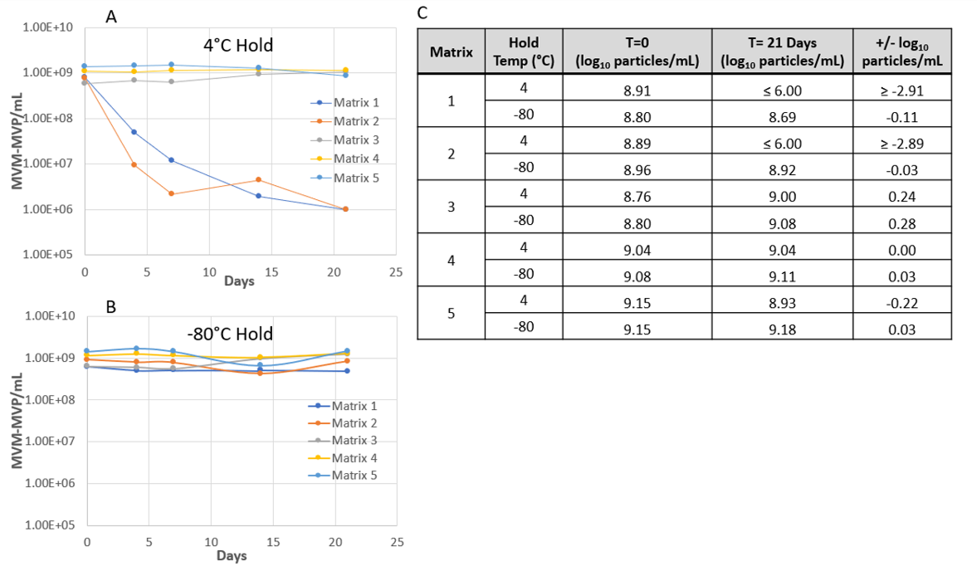
Figure 3: MVM-MVP Stability Study Results. The measurable concentration of MVM-MVP over time was charted for spiked Matrices at 4°C (A) and -80°C (B). Numerical data are summarized (C). Of note: Since an MVM-MVP spike target of 9.0 log₁₀ particles/mL was utilized, the upper LOQ of the I-qPCR was not considered when calculating Final Recovery % (C).

Virus Filtration
To determine an optimal MVM-MVP challenge in terms of process filtration, 8.0 log₁₀, 9.7 log₁₀ and 11.0 log₁₀ total MVM-MVP particles were spiked into Matrix 5 and processed through 20N filters. Figure 4 shows that for each challenge, relative flux was essentially the same (39-41 LMH) and comparable to 20N processing without an MVM-MVP spike (40 LMH). Step yield data indicate that spike challenges up to 11 log₁₀ MVM-MVP do not adversely affect overall mAb recovery.
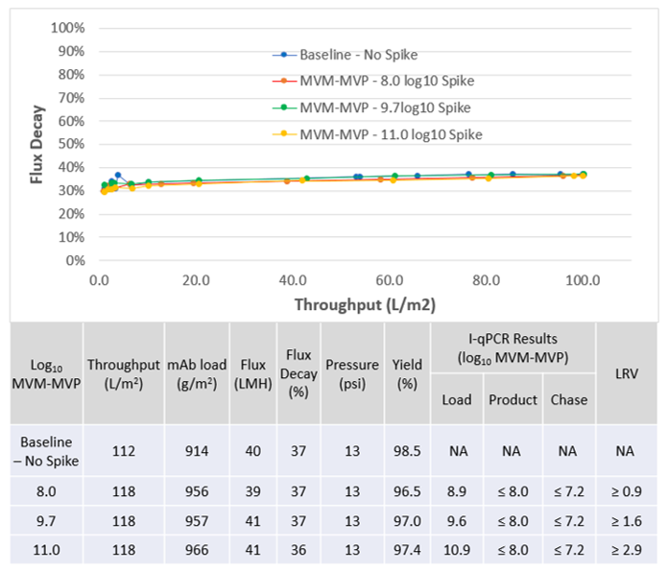
Figure 4: Preliminary 20N Results. Above) Flux decay curves for Matrix 5 baseline (no-spike) and Matrix 5 spiked with increased amounts of MVM-MVP. Below) Quantitative filtration performance and step yield data with I-qPCR results and LRV calculations. I-qPCR results denoted with “≥” or “≤” signify that the lower LOQ was achieved and values exceeding those reported could not be assumed.
I-qPCR analysis of load, product and chase samples revealed no particles for any challenge. Calculable LRV’s increased as the spike challenged increased, enabling reportable clearance of ≥ 2.9 log₁₀ MVM-MVP for the 11.0 log₁₀ MVM-MVP challenge. Because comparable filtration performance was seen at the higher load concentration, where calculation of higher LRV’s can be achieved, an 11.0 log₁₀ MVM-MVP challenge was selected for all subsequent experiments.

Based on the results of the initial virus filtration results, 15N, 20N, 35N and BioEX virus filters were challenged with either 11.0 log₁₀ MVM-MVP or 8.0 log₁₀ TCID₅₀ MVM. Relative flux, as a function of throughput, was consistent among each filter type regardless of particle challenge (Figure 5) relative to the baseline experiments with no particle spike. 15N virus filters, spiked with either MVM or MVM-MVP experienced the highest degree of normalized flux decay (57-61%) and these results were comparable to 15N onset flux seen without particle spiking (57%). Moderate flux decay was experienced during BioEX and 20N processing (25-30 and 35-36%, respectively) and negligible flux decay was observed for 35N filtration (21-23%). For all filter types, flux behavior was similar for the two particle types compared to the no particle control experiments and mAb recovery was consistent for all experiments with step yields above 94%. Complete MVM and MVM-MVP clearance was achieved for 15N, 20N and BioEX filtrations with similar calculable LRVs of ≥ 4.4 and ≥ 2.6 for MVM and MVM-MVP, respectively. These results confirm the hypothesis that MVM and MVM-MVP behave similarly when utilizing the size-based exclusion technique of virus filtration. No particles of either type were detected in the chase collected for 20N and BioEX filtrations; however, 2.8 log₁₀ total MVM was surprisingly observed in the 15N chase. Complete passage of MVM and MVM-MVP into the product filtrate was seen for the 35N virus filter.

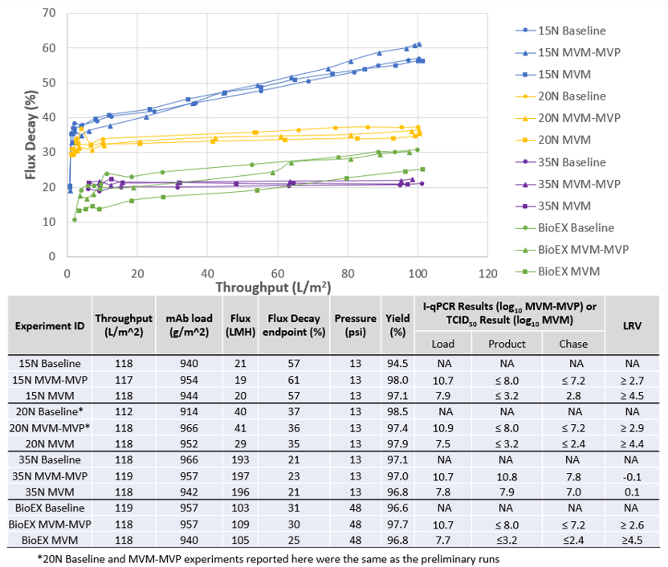
Figure 5: Virus filtration results for baseline experiments and MVM/MVM-MVP challenges. Above) Flux decay curves for all experiments with filter type grouped by color and spike type grouped by shape. Below) Quantitative filtration performance and particle clearance data. Clearance results denoted with “≥” or “≤” signify that the assay lower LOQ was achieved and values exceeding those reported could not be assumed.
AEX Gradient Scouting
Matrix 3 spiked with 9.0 log₁₀ particles/mL was processed through a Q-SFF column and fractions collected during a salt gradient were analyzed for MVM-MVP breakthrough. Pressure remained consistent throughout the run (Figure 6) and a mAb yield of 98.8% was achieved.
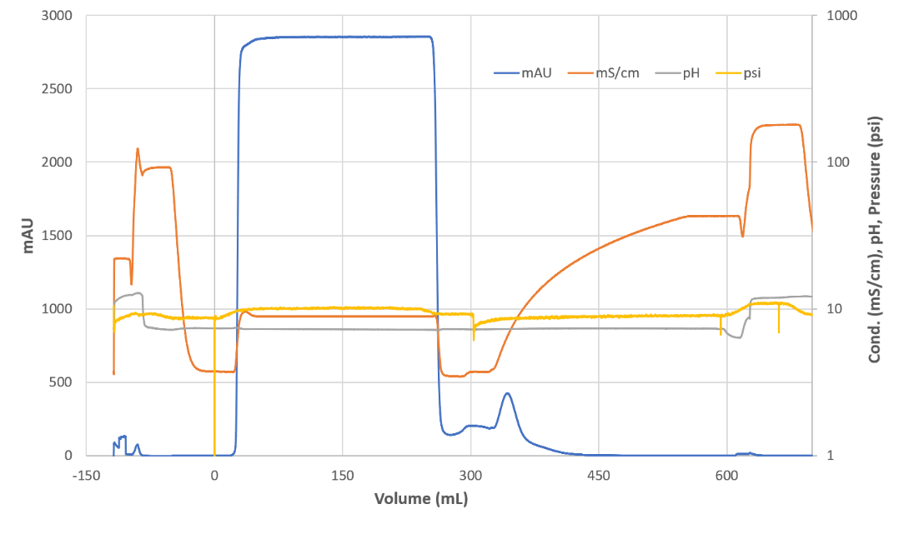
Figure 6: Chromatogram of AEX Gradient Experiment. The left vertical axis depicts UV signal (measured in mAU and shown in blue) while the right vertical axis serves to depict conductivity (measured in mS/cm and shown in orange), pH (shown in gray) and pressure (measured in psi and shown in yellow). During the column equilibrium phase, prior to loading spiked Matrix 3, volume processed was recorded as an increasing negative value.
I-qPCR analysis of the gradient fractions revealed that MVM-MVP elution began by Fraction 10, corresponding with a conductivity of ~23 mS/cm, and peaked during Fractions 11 and 12, corresponding with a conductivity of ~ 27 mS/cm (Figure 7). These results provide a window for optimization of particle clearance on AEX chromatography. In addition, load and flow through pool (pre-gradient) samples were analyzed for MVM-MVP quantity via I-qPCR. The results showed no detectable MVM-MVP in the flow through pool and an LRV of ≥ 2.9 was determined.
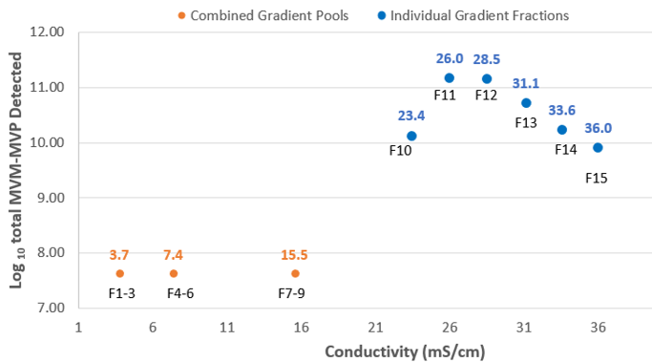
Figure 7: Graph showing the conductivity of pooled (orange) and individual (blue) gradient samples taken during the experiment and the calculated total MVM-MVP quantity, determined through I-qPCR, within those samples. Conductivity values appear over each data point while Fraction #’s appear below.

AEX: MVM vs. MVM-MVP
Based on the gradient results, MVM and MVM-MVP spiked loads were prepared and processed through AEX at four separate target conductivity conditions. Load conductivity adjustment were achieved to within ± 2.0 mS/cm of each target condition, and MVM and MVM-MVP preparations were within 0.6 mS/cm of each other (Table 4). Load pressure and mAb step yields were consistent and comparable to a historical, non-spiked, baseline. Notable discrepancies of pressure between MVP and MVM are attributed to differing chromatography instruments (AKTA Avant for baseline and MVP, and AKTA Pure for MVM). No abnormal processing events occurred during any of the runs. Load (neat and 1:10 in PBS), product and strip samples were analyzed for MVM and MVM-MVP quantity via TCID₅₀ and I-qPCR, respectively.
Table 4: Results from load conditioning, processing and clearance analysis for MVM and MVM-MVP spiked AEX Runs. Non-spiked baseline data are shown as a historical comparison, although pooling criteria was 0.5 – 0.5 OD.
Condition (Target Conductivity) | Spike Article | Actual Cond. | Max Delta Pressure (psi) | Step Yield (%) | Log₁₀ Particles  (TCID₅₀ or I-qPCR) |  |  | LRV
 |  |  |  |  | Load | Product | Strip
A (10 mS/cm) | MVM-MVP | 9.4 | 12.9 | 100 | 11.36 | ≤ 8.37 | ≥ 10.83 | ≥ 2.99
 | MVM | 8.8 | 4.2 | 101 | 8.19 | ≤ 3.52 | 8.06 | ≥ 4.67
B (21 mS/cm) | MVM-MVP | 19.5 | 12.9 | 101 | 11.29 | ≤ 8.38 | ≥ 10.84 | ≥ 2.91
 | MVM | 19.9 | 5.4 | 100 | 8.18 | 5.19 | 7.75 | 2.99
C (24 mS/cm) | MVM-MVP | 22.2 | 13.8 | 102 | 11.37 | 8.93 | ≥ 10.84 | 2.44
 | MVM | 22.1 | 4.1 | 99 | 8.18 | 6.76 | 7.97 | 1.42
D (41 mS/cm) | MVM-MVP | 41.2 | 14.4 | 100 | 11.25 | 11.38 | 8.35 | < 1*
 | MVM | 41.2 | 4.2 | 98 | 8.02 | 8.42 | 5.73 | < 1*
Historical Baseline  (10 mS/cm) | NA | NA | 9.9 | 93 | NA
* considered insignificant according to Q5A guidelines¹⁵
The results show that complete MVM clearance occurred at the low salt Condition A (LRV ≥ 4.67) while partial clearance occurred at Conditions B and C (LRVs of 2.99 and 1.42 respectively). No MVM clearance (full passage) occurred at the high salt Condition D. (LRV < 1). In comparison, complete MVM-MVP clearance was achieved at low salt with the I-qPCR LOQ limiting a reportable LRV to ≥ 2.99. Complete MVM-MVP clearance was also measured at an operating conductivity of 21 mS/cm (LRV ≥ 2.91). Partial clearance was measured at Condition C (LRV 2.44) while full passage was determined at high salt Condition D (LRV <1). These results confirm that both MVM and MVM-MVP behave similarly when utilizing an AEX chromatography separation.
Independent I-qPCR Analysis
Samples of VF and AEX load, product, chase or strip taken throughout the study were measured for MVM-MVP quantity via I-qPCR at Texcell N.A., as described in the methods section. In parallel, these samples were stored at -80°C, thawed and measured at MedImmune. A comparison of the results reveals that, in instances when complete MVM-MVP clearance was achieved, the I-qPCR LOQ was determinant for LRV calculation at both independent sites of analysis (Figure 8). In instances when complete passage of MVM-MVP occurred, I-qPCR data from either site generated LRVs of ~0.0. For the AEX Condition C experiment operated at a conductivity of 24 mS/cm, partial clearance of MVM-MVP was determined at both sites with an LRV discrepancy of only 0.04. These results show the reproducibility of the assay and sampling at multiple sites and technicians with accurate results.
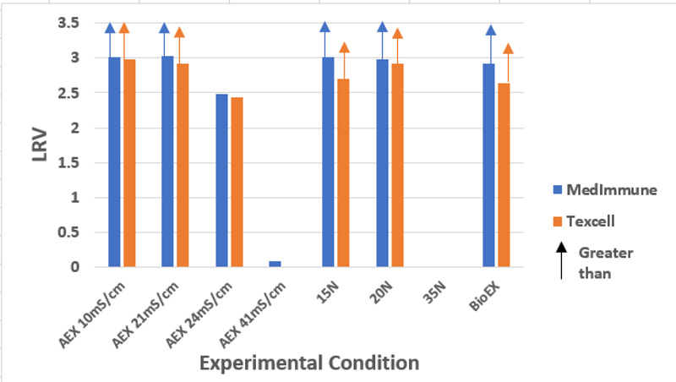
Figure 8: Independent LRV calculations from two analytical sites, MedImmune (blue) and Texcel N.A.l (orange) are shown for each experiment. LRV results determined from product sample measurements below I-qPCR LOQ are shown to have arrows directed above.
I-qPCR Analysis of MVM
Select MVM samples collected during VF and AEX experiments were analyzed for MVM quantity via I-qPCR. The results (Table 5) show that a higher MVM quantity is consistently observed when measured via I-qPCR vs. TCID₅₀, likely due to the presence of non-infectious MVM particles as discussed below.
Table 5: I-qPCR vs. TCID₅₀ Results for Comparative MVM Samples
Sample | I-qPCR (Log₁₀) | TCID₅₀ (Log₁₀) | Difference (Log₁₀)
15N Load | 9.24 | 7.92 | 1.32
20 N Load | 9.22 | 7.52 | 1.70
BioEX Load | 9.21 | 7.68 | 1.53
AEX Condition A Load | 9.51 | 8.19 | 1.32
AEX Condition A Strip | 9.25 | 8.06 | 1.19
AEX Condition B Load | 9.52 | 8.18 | 1.34
AEX Condition B Strip | 9.21 | 7.75 | 1.46
AEX Condition C Load | 9.59 | 8.18 | 1.41
AEX Condition C Product | 8.46 | 6.76 | 1.70
AEX Condition C Strip | 8.94 | 7.97 | 0.97

Discussion
We sought here to assess the accuracy and practicality of predicting MVM clearance with a non-infectious MVM-MVP particle through virus filtration and AEX modes of separation. First, spike/recovery and hold time studies were conducted with a panel of industry-representative, in-process matrices. No matrix effects were seen to interfere with I-qPCR analysis as all undiluted MVM-MVP recoveries were within ± 0.15 log₁₀ particles/mL of a spiked PBS control value. Hold time data revealed that spiked/processed samples stored at -80°C retain a consistent MVM-MVP concentration for at least 21 days. After preliminary 20N results elucidated an optimal virus filtration spiking challenge, we observed comparable flux decay profiles among 15N, 20N, 35N and BioEX virus filters challenged with 8.0 log₁₀ TCID₅₀ MVM and 11.0 log₁₀ MVM-MVP spiked loads. TCID₅₀ and I-qPCR data from these experiments demonstrated consistent clearance trends between MVM and MVM-MVP challenged runs; full clearance of either particle when processed through 15N, 20N and BioEX and full passage of either particle when processed through 35N. The I-qPCR analysis of salt gradient fractions collected during a preliminary MVM-MVP spiked AEX run helped establish a series of target load and processing conductivities for comparable MVM vs. MVM-MVP clearance experiments. These experiments revealed that: 1) at low salt conditions (10 mS/cm) each particle type was fully retained by the Q-SFF column and LRVs were generated from assay LOQ values, 2) at high salt conditions (43 mS/cm) each particle freely passed through the resin into the product pool and no LRVs were achieved, 3) at an intermediate salt condition of 21 mS/cm, partial clearance of MVM was achieved while the I-qPCR assay was unable to detect MVM-MVP passage into the product pool, and 4) at an intermediate salt condition of 24 mS/cm, incomplete passage of each particle type was confirmed through TCID₅₀ and I-qPCR analysis and a 1.0 LRV difference between particle types was determined. These results met our overall expectations of accurately predicting MVM clearance through the MVM-MVP surrogate.
Unlike MVM, MVM-MVP particles are non-infectious and lack genomic nucleic acid sequences. This precludes them from quantification by standard mammalian cell culture based infectivity assay (TCID₅₀) and qPCR. Instead, an I-qPCR technique was developed to synergize the specificity of an antibody-antigen interaction with the sensitivity of qPCR. MVM-MVP concentrations of samples collected during the course of this study were analyzed by back-calculating Threshold Cycle (Ct) values to a universal standard curve generated from the average values obtained from ten separate 10-fold dilution series of known MVM-MVP concentrations. A lower LOQ was set to lowest dilution series concentration whose average Ct values were significantly different to an accumulated average of buffer blank Ct signals according a Students T test. This value (6.0 log₁₀ particles/mL) represents the background signal inherent to the assay. Although most MVM-MVP Ct values generated from AEX and virus filtration pool samples were below this limit, the LOQ was utilized to calculate LRV’s. At times, this relatively high LOQ constricted LRV comparisons between MVM-MVP and MVM; however, I-qPCR assay performance was consistent, as demonstrated from independent sample measurement at Texcell N.A. and MedImmune (Figure 8) and enabled adequate trends to be determined for proof-of-concept assessments. Further improvements to the assay are being undertaken to extend the dynamic range of detection.
In-process mAb solutions were utilized as load material for MVM/MVM-MVP virus filtration and AEX spiking experiments during this study. The basic pI of the mAb (8.4-8.9), impurity profiles of the in-process material and buffer/salt compositions of the five matrices tested were representative of typical AEX and virus filtration mAb process steps. Matrix interference studies, conducted prior to spiking studies, verified the ability of the I-qPCR assay to accurately determine MVM-MVP in each of these heterogeneous solutions. Moreover, recoveries of greater than ± 30% were accomplished with “neat” analysis of each matrix. This eliminated the need to dilute samples collected during MVM-MVP spiking experiments which may have otherwise reduced LRV determinations.
For the practical implementation of an MVM-MVP spiking study, samples generated during the course of a study would have to retain a stable measurable MVM-MVP concentration during storage prior to I-qPCR analysis. Depending on a typical analytical lab workflow, the time needed to accomplish the assay could be a matter of hours, days or weeks. Storage of Matrices 1-5, spiked with 9.0 log₁₀ particles/mL, at 4°C and -80°C were evaluated for 21 days. In addition, experimental samples analyzed at MedImmune after 118 days of -80°C storage were evaluated. These samples showed a variability of 0.3 log₁₀ from the results evaluated at Texcell within 21 days (data not shown). The results from Matrices 1-5 revealed that all samples held at -80°C measured ± 0.30 log₁₀ particles/mL of original MVM-MVP concentration while at 4°C, only Matrices containing mAb maintained a quantifiable amount. The reason for the abrupt decrease in measurable MVM-MVP concentration in Matrices lacking mAb at 4°C is unknown though it may be related to surface adhesion of MVM-MVP in the absence of surfactant or protein; because of this uncertainty, and because the MVM-MVP was consistently stable when it was stored at -80°C, we chose to store all AEX and VF samples collected at -80°C prior to I-qPCR analysis.
Preliminary MVM-MVP spiking experiments were conducted on 20N filters to assess the impact of increasing particle challenges on flux decay and LRV. The results (Figure 4) demonstrated that 20N flux decay remained consistent when challenged with 8.0 -11.0 log₁₀ MVM-MVP (11.0 – 14.0 particles/m²) and was comparable to non-spiked load. These data are consistent with early MVM-MVP findings¹³ and may indicate that the pore plugging mechanism for Planova filtration is dominated by feed stream properties such as mAb concentration, impurity profile, viscosity and buffer composition as opposed to particle induced fouling. In addition to consistent flux decay for the differently spiked experiments, complete MVM-MVP removal was achieved for each spiking challenge. The higher challenge in the load enabled larger LRVs to be determined. Thus, for all subsequent virus filtration experiments, a load challenge of 11.0 log₁₀ MVM-MVP particles was employed. Although it has been reported¹⁶ that overloading of small-virus retentive filters can occur with MVM challenges above ~9.0 log₁₀, we reasoned that a spike of ~ 9.0 log₁₀ MVM particles, as measured through TCID₅₀, contains multiple log₁₀ of non-infectious particles, un-accounted for via infectivity assay. These particles would also contribute to filter fouling and therefore an 11.0 log₁₀ MVM-MVP challenge, as measured indiscriminately by I-qPCR, might be on par with a 9.0 log₁₀ total (infectious plus non-infectious) MVM particle challenge. This approach was vindicated after comparing the MVM titer results of samples taken during the course of the study by TCID₅₀ (infectious only) and I-qPCR (total particles). The results from this comparison (Table 6) show that MVM titers were consistently 1.0-1.5 log₁₀ higher when measured by I-qPCR vs. TCID₅₀ suggesting that a 9.0 log₁₀ TCID₅₀ MVM titer may contain ~ 10.0-10.5 log₁₀ total particles.
For MVM-MVP to serve as a predictive MVM surrogate, it must demonstrate comparable clearance to MVM through physicochemical based separations. We first compared the removal of each particle, in parallel, through Planova and BioEX virus filtration spiking studies. Representative in-process mAb material was used as load material while virus filters were processed to a capacity of ~1,000 g/m². The results showed complete clearance of either particle when processed through 15N, 20N and BioEX filters below the LOQ of the respective assays and showed full passage of both particles for the 35N filter. Unexpectedly, 2.8 log₁₀ total MVM was observed in the 15N chase. This result may have been attributed to system depressurization immediately preceding chase, a phenomenon that has led to reports on increased parvovirus breakthrough¹⁷⁻¹⁸. In contrast, no MVM-MVP was observed in the 15N chase, either because none was present or because it was unobservable given the limits of the assay. A comparison of the flux decay profiles from loads spiked with either particle suggest a common virus filter fouling mechanism for experiments performed with the two particles. Consistent high mAb yields were achieved from each run. These results confirm the overall physical-similarities between the MVM-MVP and MVM, and the results help validate the practical application of MVM-MVP for use in predictive virus filtration studies. Limitations on LRV comparisons between MVM-MVP and MVM currently exist primarily due to the higher LOQ of the I-qPCR assay but this limitation is expected to diminish as improvements are made to the quantification assay.

An earlier physicochemical study demonstrated the surface pI of MVM-MVP and MVM to be 5.81 and 5.99 respectively¹². Based on these results, the two particles should theoretically behave similarly through ion exchange modes of separation, such as AEX. Before comparing removal of either particle in head-to-head spiking studies, an MVM-MVP spiked salt gradient experiment was conducted to scout for operating conductivity points of interest. Fractions analyzed from this experiment allowed us to determine that MVM-MVP breakthrough occurred at ~23 mS/cm (Figure 7). These data enabled us to select four spiking conductivity conditions for MVM vs. MVM-MVP comparative analysis: 10, 21, 24 and 41 mS/cm. The achievement of complete clearance of either particle at 10 mS/cm and passage of either particle at 41 mS/cm (see Table 4) was in line with expectations. At a load conductivity of 21 mS/cm, low amounts of MVM were quantifiable in the flow through product collection as electrostatic forces hindered by the presence of salt ions decreased the capability of the Q-SFF column to retain the negatively charged particles; however, the amount of quantifiable MVM-MVP was below the I-qPCR LOQ and therefore no breakthrough was detected. At 24 mS/cm, both MVM and MVM-MVP were quantifiably present in the product collection which enabled a direct LRV comparison and an LRV difference of 1.0 log₁₀ was seen for the two particles. This may be attributable to the impact that different total particle challenges had on AEX clearance of MVM and MVM-MVP; however, more comparative data should be generated and analyzed before quantitative accuracy conclusions should be made. As a whole, the results from these comparative experiments demonstrate a positive correlation between MVM-MVP and MVM clearance through Q-SFF and indicate the ability of MVM-MVPs to predict salt-induced hinderance of MVM retention.
Conclusion
Overall, the VF and AEX data gathered throughout this study supports the potential to utilize MVM-MVP as a practical and accurate surrogate for MVM clearance prediction during downstream process development studies. The ability of the I-qPCR assay to consistently quantify MVM-MVP content in a variety of in-process matrices and the ability to freeze samples at -80◦C without negative impact to analytical accuracy support this technique from a practical perspective. The non-infectious nature of MVM-MVP and the I-qPCR assay also provides practical use of the kit in typical development and analytical lab spaces without the risks associated with BSL-2 agents. Virus filter flux decay profiles, AEX chromatogram analysis and step yield calculations were also indicative of MVM-MVPs real-world potential. In terms of MVM prediction accuracy, complete MVM-MVP clearance was achieved in every case where complete MVM clearance occurred (Planova 15N, 20N, BioEX and AEX Condition 1) while complete MVM-MVP passage was achieved in every case where complete MVM passage occurred (Planova 35N and AEX Condition 4). When un-incumbered by assay LOQ, MVM-MVP Q-SFF breakthrough accurately coincided with the partial breakthrough of MVM (AEX Condition C). With improvements to the I-qPCR forthcoming, the range of MVM-MVP’s predictive ability should increase along with its utility as a practical, accurate and economical MVM surrogate.
References
1. Liu HF, Ma J, Winter C, Bayer R. Recovery and purification process development for monoclonal antibody production. MAbs. 2010;2(5):480-499.
2. Savino E, Hu B, Sellers J, Sobjak A, Majewski N, Fenton S, Yang T Y. Development of an in-house, process-specific ELISA for detecting HCP in a therapeutic antibody, Part 2. BioProcess Intl. 2011;9(3):38-49.
3. Castro-Forero AA, Jokondo Z, Voloshin A, Hester JF. Anion-exchange chromatographic clarification. BioProcess Intl. 2015;13(6):52-57.
4. Wang X, Schomogy T, Wells K, Mozier N M. Improved HCP quantitation by minimizing antibody cross-reactivity to target proteins. BioProcess Int. 2010;8(1):18-24.
5. Mehta S, Keer JT. Performance characteristics of host-cell DNA quantification methods. BioProcess Intl. 2007;5(9):44-58.
6. Wang X, Morgan DM, Wang G, Mozier NM. (2012). Residual DNA analysis in biologics development: review of measurement and quantitation technologies and future directions. Biotechnology and bioengineering. 2012;109(2):307-317.
7. Rathore AS, Sofer G. Process validation in manufacturing of biopharmaceuticals. CRC press., 2012.
8. Connell‐Crowley L, Larimore EA, Gillespie R. Using high throughput screening to define virus clearance by chromatography resins. Biotechnology and bioengineering. 2013;110(7): 1984-1994.
9. Curtis S, Lee K, Blank GS, Brorson KA, Xu Y. Generic/matrix evaluation of SV40 clearance by anion exchange chromatography in flow‐through mode. Biotechnology and bioengineering. 2003;84(2):179-186.
10. Roldão, A., Mellado, M. C. M., Castilho, L. R., Carrondo, M. J., & Alves, P. M. “Virus-like particles in vaccine development.” Expert review of vaccines (2010): 9(10), 1149-1176.
11. Buonaguro, F. M., & Buonaguro, L. “Virus-like particles in vaccine development.” Virus, (2014): 2-4.
12. Johnson S, Brorson KA, Frey DD, Dhar AK, Cetlin DA. Characterization of Non-Infectious Virus-Like Particle Surrogates for Viral Clearance Applications. Applied biochemistry and biotechnology. 2017;183(1):318-331.
13. Cetlin DA, Pallansch M, Fulton C, Vyas E, Shah A, Sohka T, Dhar AK, Pallansch L, Strauss D. Use of a Noninfectious Surrogate to Predict Minute Virus of Mice Removal During Nanoﬁltration. Biotechnology Progress. 2018;34(5):1213-1220.
14. Miesegaes, George, Scott Lute, and Kurt Brorson. "Analysis of viral clearance unit operations for monoclonal antibodies." Biotechnology and Bioengineering 106.2 (2010): 238-246.
15. International Conference on Harmonisation (ICH). "Q5A (R1). Viral safety evaluation of biotechnology products derived from cell lines of human or animal origin." (1997).

16. Lute S, Bailey M, Combs J, Sukumar M, Brorson KA. Phage passage after extended processing in small-virus-retentive filters. Biotechnol Appl Biochem. 2007;47(3):141–151.

17. Asper M. Virus breakthrough after pressure release during virus retentive filtration. PDA Virus/TSE Safety Conference. Vol. 27. 2011.
18. Strauss D, Goldstein J, Hongo‐Hirasaki T, Yokoyama Y, Hirotomi N, Miyabayashi T, Vacante D. Characterizing the impact of pressure on virus filtration processes and establishing design spaces to ensure effective parvovirus removal. Biotechnology progress. 2017;33(5):1294-1302.

